# Contract Budget Module Monthly Procedure

Just for Actuals to apply to COBRA (correcting Assigned Budget is done separately)

This process must be completed prior to loading any actuals in to COBRA. In order to encompass any BCR changes, etc. a reconciliation must be done between the current working months Baseline file and the Contract Budget Module.

## Run the Update Actuals “Report Only?”

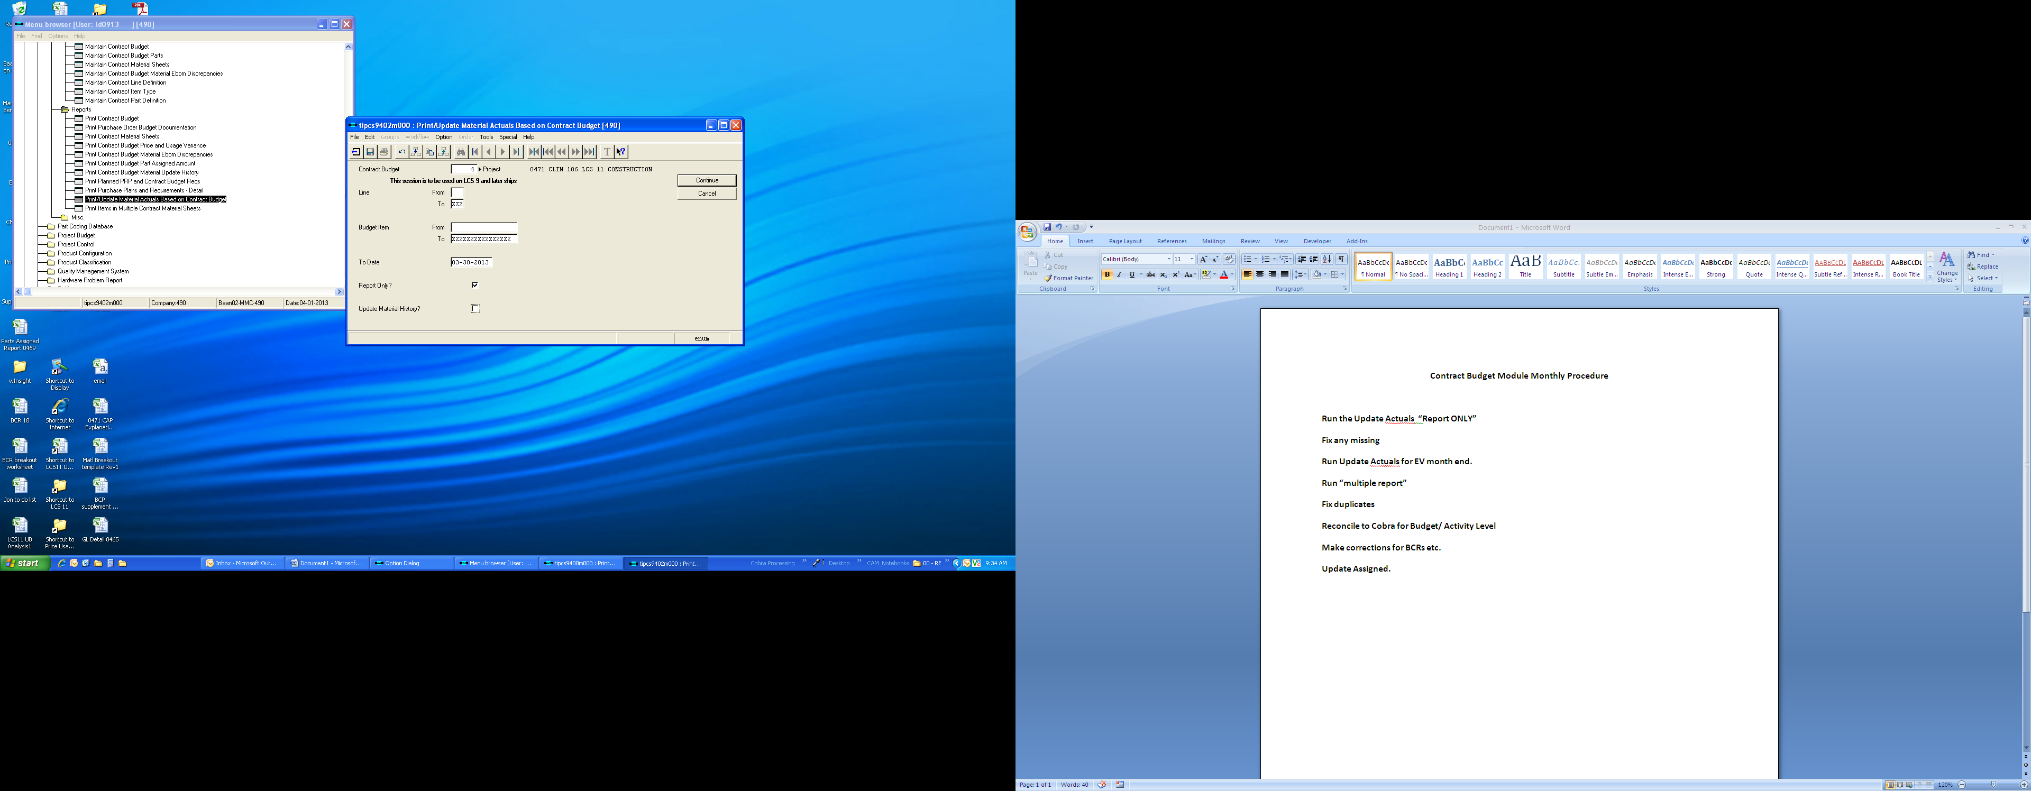

* + Use Budget number (5,2,3,4…..)
  + Check mark on “Report Only?”
  + Date should be EV month end date.
  + Use material Actuals Report – Summary
  + Choose device, click continue twice (two consecutive reports will be created)
* The first report will show which activities are not mapped to a control account
* The second report will show you items that have had actual against them in the reporting period, but are missing in the CBM

## Fix any missing Items on the Second Report

* You must research missing part numbers and make proper entries
  + “Budget Item Not Found” = Part number not in the CBM
  + “Activity Not Found” = Actuals hitting an Activity that is not mapped
  + Journal Entries will go to the commodity account of the GL number used (i.e. GL# 4250 would go to Matl-250-999) since there is no Item number.
  + Once you have found proper placement of part number you must enter it in to the CBM (See work instructions)

## Run Update Actuals for EV month end (see next page)

* Same as the first time but make certain to check “Update material History?”
* This will apply the actuals to the CBM which COBRA will pull

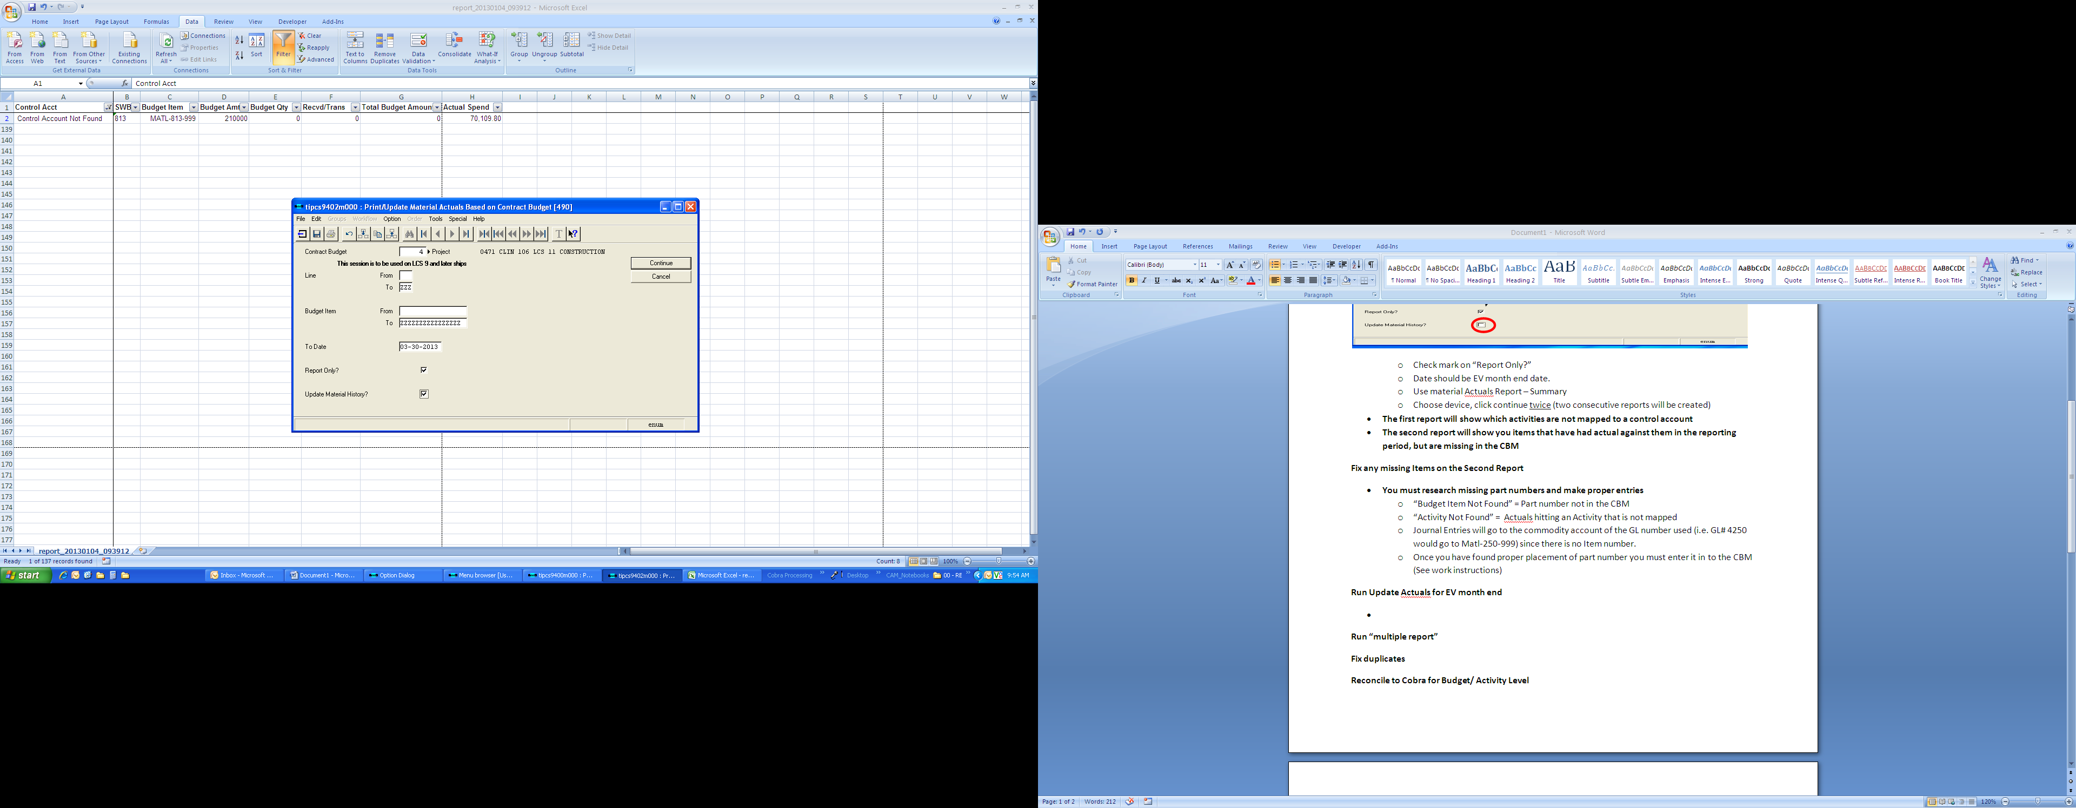

## Run “Print Items in Multiple Contract material Sheets” report

* This report will find duplicate part numbers in the CBM by project
* Some duplicates are valid such as parts ending with –MISC (budget place holders)
* Fix accordingly

## Reconcile to Cobra for Budget/ Activity Level

* Run “Print Contract Budget Part Assigned Amount” (tipcs9494m000)
  + Enter Project number (0465,0467,0469,0471)
  + Check all four “Discrepancies” selections
  + Place “-1” for both “Tolerance Pct”

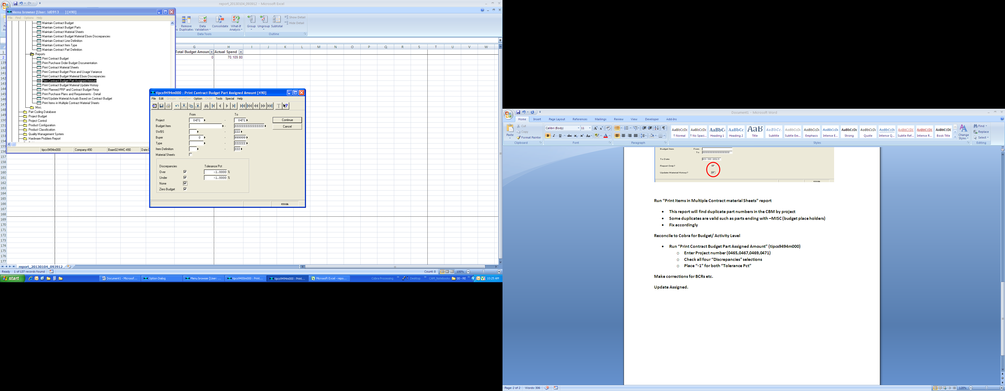

* + Select “Detail Budget Parts List – Excel” for Report
  + Once the report is in Excel run a filter and filter column H (Assigned Amt) and de-select the 0.00 amount.
* Now run a SUMBYCST report in COBRA to reconcile to
  + Use “Material Only” filter
  + Choose “WP” as criteria, uncheck Sub-total – click next
  + Choose “BCWS” (Budget) as the Cost Reporting Set – Click next
  + When report is finished copy and paste in to the Baan report workbook as a separate tab
* Reconcile
  + Remove blank spaces in front of Baan report “Activities” Column (use Find Replace) in column A
  + Insert two columns in between G and H
  + Create a Vlookup to reference the COBRA report you have pasted in to the other sheet, in column H, referencing column A “Activity” and returning the COBRA budget amount
  + In column I find the difference ( i.e. =G350-H350), this will give you discrepancies
  + Part numbers must be found to “Assign” the budget to within the Activity. The Activity and the Budget amounts are only half of the data in the CBM.

## Update Assigned

* After all corrections and changes are made, you must update the assigned amount within the CBM.
  + Update Assigned Amount (tipcs9291m000)
  + Run for project specific number